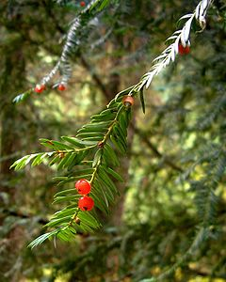

SYLLABUS
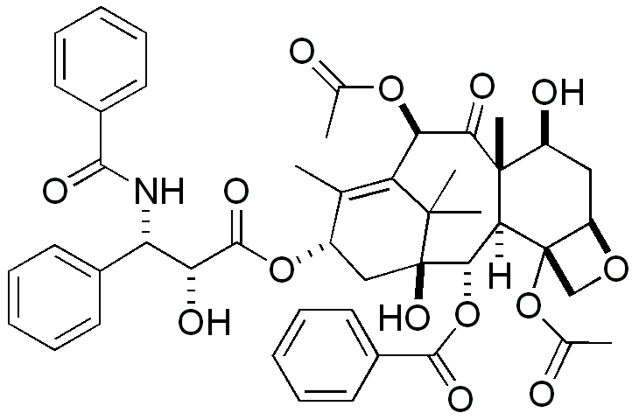

Department Name: Natural Sciences

Course Number: Chem 3800

Course Title: Organic Chemistry I

Units: 3 units

Semester offered: Summer 2026
Modality: Hybrid – self paced paclitaxel (Taxol^{®)} Taxus brevus
(anti-cancer therapeutic) Pacfic Yew tree
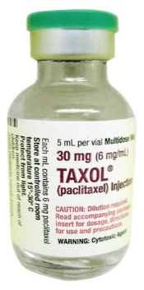
Course Meeting Time: 10:30 - 11:40am
Course Meeting Days: In person exams only: 6/22; 6/29 & 7/7
Course Meeting Place: Meadowlands 106:
- (self paced)
instructional video tutorials

Prerequisites: Chem 2000/5; Chem 2100/5
Co-requisite: Chem 3805 (Organic Chemistry Lab)

Instructor Information:
Name: Tyler Johnson, PhD
Office Phone: 415-482-1983

Office Hours: Monday, Wednesday, Friday 12:00-1:00 pm (by Zoom)
Office Location: 128 Science center & Zoom

e-Mail Address: tyler.johnson@dominican.edu
web: https://thejohnsonlab.wixsite.com/johnson-chem3800

Teaching Assistant (TA) / Tutor: Matthew Nickel - Matthew.Nickel@dominican.edu
If anything is unclear to you - please Reach out – we’re all here to HELP STUDENTS

DESCRIPTION OF SYLLABUS CONTENTS

1. Course Description: General Content of the Course
Introduction to the fundamental concepts of organic chemistry focusing on chemical structures, bonding, stereochemistry and chemical reactivity. We encounter organic (carbon-based) compounds on a daily basis and the general public has to take the media’s word for whether these chemicals are “good” or “bad.”
Through learning organic chemistry, you will gain a deeper understanding of the world around you – from molecules involved in environmental chemistry to therapeutic lead structures used to treat diseases.
This course covers the fundamentals of organic chemistry: nomenclature, structures in 2 and 3 dimensions, chirality, reactions, reaction mechanisms of simple organic molecules such as alkanes, alkenes, alkynes, aromatics, alkyl halides and applications in Mass spectrometry and NMR as they relate to the field of Bioorganic and Medicinal Chemistry citing selected scientific publications.

2. General Education or Major Requirements Satisfied by the Course:

This course satifsfies the requirements for a biology and chemistry degree.

3. Learning Outcomes
This course satisfies the following Chemistry Program Learning Outcomes:
PLO 1. Students will comprehend and integrate the fundamental scientific concepts and laboratory skills in the chemical and physical sciences.
PLO 2. Students will apply scientific and mathematical principles in the design, execution and comprehension of an independent research project.
PLO 3. Students will demonstrate effective communication skills in written and oral presentations of scientific research.
PLO 5. Students will demonstrate readiness for further study or employment in discipline related areas.
This course will also allow students to acquire the following institutional learning outcomes
ILO 1 Exploration and Acquisition of Knowledge
ILO 2 Development of Intellectual, Professional, and Artistic Skills

4. Texts and Resources: Text: Organic Chemistry 9th edition McMurray. ISBN-13: 978-1305080485
Study guide with Solutions manual: Organic Chemistry 9th edition McMurray. ISBN-13: 978-1305082144

Molecular Model Set (Optional but Highly Recommended): If you have one, you use can use it on the exam(s).
Prentice Hall Molecular Model Set for General and Organic Chemistry. 1998. ISBN-13: 9780139554445.

5. Library Support: Library Liaison: Amy Gilbert, amy.gilbert@dominican.edu, 415-257-1329

6. Online Components - course website: https://thejohnsonlab.wixsite.com/johnson-chem3800

Our lectures will be available online as instructional tutorial videos. NOTE: During lecture video tutorials - the instructor will often write on a white board. However the student is NOT expected to draw what’s on the whiteboard – rather what’s on the slide, which is the sourse for where the instructor is drawing from to slow down the “tempo” of the lecture.

7. Academic Honesty Honor Code. Students are expected to adhere to the Academic Honesty Honor Code stated in the Catalog. Students should practice academic integrity in all of its forms, including abstaining from plagiarism, cheating, and other forms of academic misconduct. The University reserves the right to determine in any given instance what action constitutes a violation of academic honesty and integrity.
Our course policy on cheating involves the following guidelines which include:
1) Any student caught using a: a) graphing calculator, b) smart phone, c) smart watch or
d) unauthorized supplementary device during an exam will receive a 0.
2) Students are encouraged to use the restroom prior to each 70 minute exam. Students may not be allowed to use the restroom during a 70 minute exam. Professional notes from a physician will be an exception.
3) No make up exams will be provided. Students missing an exam can take the weighted average score of their scores from two of the three exams given if they miss an examination.
If more then one exam is missed by a student, they may be advised to withdraw from the course.
Students must complete the final exam to pass the course. Make up exams will be proctored by a faculty or staff member and if one is not available the student will take the make up exam under video surveillance. Individual circumstances will be evaluated at the instructor and the NSM department chair’s discretion.
The above guidelines have been set in place to create democracy and equity for everyone in the classroom.
Please do not take them personally, just take them seriously.

8. Diversity
Dominican University of California is committed to promoting diversity. In recognition of our diverse backgrounds, the inclusion of diverse thought is encouraged in this course and in all classroom interaction. In addition, in this course, an effort will be made to provide a learning environment which is conducive for all students.

9. Assignments
Students are expected to read ahead in the textbook based on the tentative schedule. Assignments include homework and in-class worksheets. In-class exams will also be administered. Problem sets: Textbook problems will be assigned (weekly in lecture) to help master the course material. The textbook homework will NOT be turned in or graded for points. It is the responsibility of the student to complete the assigned homework (p. 4) for the course on time in line with the proposed outlined schedules on page 5. Our homework questions will serve as approximately 50% of our exam material.

IMPORTANT NOTE:
Working problems is essential to learning organic chemistry. It'll be difficult for you to solve problems on quizzes or exams if you do not PRACTICE working similar problems while you are studying. It’s to your advantage to use the solutions manual to check your answers. Keeping all of your worked-out problems in an organized folder provides the foundation for review material involving our exams.

10. Grading: Organic Chemistry Lecture & Lab will be graded separately. A separate grade will be reported for both courses to assess your strengths or weaknesses involving the lecture material and or a laboratory setting.

Exam 1 200 pts
Exam 2 200 pts
93-100% A
90-92% A-
87-89% B+
83-86% B
80-82% B-
77-79% C+
73-76 C
70-72 C-
60-69% D
< 59% F
0-59% F
Exam 3 200 pts
Total 600 pts

NOTE: We structured this course to simulate preparative courses that prepare students for the:

a) Optometry Admissions Test (OAT), b) Dental Admissions Test (DAT) or c) Medical College

Admissions Test (MCAT). After taking these entrance exams (a-c), students are not provided their

exams or able to view which question(s) they missed. They are provided their percentile score

overall out of 100%. Similarly, our exams will not be passed back to students. Exam scores will

be emailed to each student. Students can view the question(s) they missed on our exams during

office hours in person with their instructor. Exams will be drawn from approximately ~85%

1) Worksheets and 2) HW questions with ~15% drawn from new but related material based on 1-2.

11. Expectations for Students
Please turn off cell phones during class and practice respect for your fellow students and the instructor. Texting friends and family during class can be distracting to your fellow students and instructor. Materials posted to the course web site are only for class use and may not be duplicated and distributed or sold. Students may download and print information for personal use as a student in the class. This is consistent with Fair Use under intellectual property protection. Expect to spend a minimum of three hours outside of class for every one hour of class. Students must come to class on time and attend all lectures. Teamwork is essential and encouraged on class assignments , however completing assignments is the responsibility of each student.
We do not field questions on our lectures, worksheets, homework or practice exams by email. Organic Chemistry involves structures, graphics, and reactions/mechanisms with visual/spatial awareness - so email is not a proper venue to answer questions here. Students are encouraged to ask questions in office hours
PRIOR TO EACH LECTURE – PLEASE READ THE OUTLINED SECTIONS IN OUR TEXT (see page 5)

12. Students Who Require Accommodations:
Dominican University of California is committed to equal access for all students in accordance with the American’s with Disabilities Act of 1990. Students who feel they may need accommodations based on the impact of a disability should contact the Office of Accessibility and Disability Services at 415-257-1388 asap to discuss specific accommodations. Please submit the subsequent paperwork to the instructor asap.

13. Course Evaluations Dominican University of California is committed to an ongoing evaluation of its

programs and courses through a culture of constructive dialogue and feedback. It is expected that students will complete the course evaluation either in class or outside of class. The instructor will determine time for the course evaluation to be completed. A link to the course evaluation will be sent to all the students enrolled in the class by the IT Department. The evaluation may be completed on any electronic device.

14. Title IX
As instructors, one of our responsibilities is to help create a safe learning environment for our students and for the campus as a whole. As part of our commitment to students' well being, we have the responsibility to report any instances of sexual harassment, sexual violence, relationship violence, or stalking to our Title IX Coordinator, so they can inform students about their reporting options and the various support resources available. Student privacy is a priority for us and will be maintained to the extent permissible by law and policy. For more information about your rights and reporting options, including confidential and anonymous reporting, please visit dominican.edu/titleix.

15. Disclaimer This syllabus is subject to modification. The instructor will inform students of changes.
Homework – Organic Chemistry (McMurray) 9th edition (To be presented in lecture)

Chapter: Problems

Ch 1: 5a,c,e, 6, 8-15, 28, 34, 38, 42, 47, 50, 51

Ch 2: 1-3, 6-8, 10, 19, 30, 32, 35-38, 40 (Skip 42), 44, 48, 55, 59, 61,

Ch 3: 1, 3-5, 7-9, 11, 12, 14, 16-18, 22, 25, 29, 31a-c, 35, 38, 42, 43, 53

Ch 4: 1, 2, 4-7, 9, 11, 12-15, 18, 30, 35-39, 42, 45

Ch 5: 5a: 1-3, 8, 10, 30, 32, 37, 42-46 5b : 13, 14, 16, 17, 21, 38, 65

Ch 6: 1, 4-7, 8a,b, 9,10, 12, 13, 17, 19, 21, 22,* 30, 31, 34, 35a,b,

Ch 7: a) 1, 2a-c, 4-6, 9, 10, 11, 13, 15, 34d-f,^^ 36, 38, 39a-c, b) 16-18, (skip 21), 57-60a-b (skip c)

Ch 8: a) 1, 3, 5-10, 12-16, 36, 42 (skip e), 43 (skip f), 58, 59, 61, 67; b) 33, 44 b and c, 50 (skip c)

Ch 9: 1, 3-6, 8-13 (skip 9b), 27a-e, 31, 32, 34a-c, 36, 37, 38, 40, 46, 53,

Ch 10: 1-2, 8, 9, 11, 25**, 26 (skip c), 40, 44

Ch 11: a) 2-8 (skip 7), 12-13, 31, 41-47, 54, 56, 57, 60; b) 15-17, 19, 20a-c, 50, 51, 62, 66, 70, 77

Ch 12: 2-4; 14-16, 17, 19-26, 25*** 39

Ch 13: 6, 9a-c 10a,b, 11, 33, 34, 36-39.

NOTES: UPDATED 11/26/25
*Solutions manual typo: change: “…Problem 6.29 shows…” to “…Problem 6.25 shows…”
^^An easier formula then in our book to determine degrees of unsaturation (DoU) is:
DoU = (2C + 2 + N – H – X) =
2
Where in the given molecular formula: C = Carbon
(e.g. C₆H₁₂N₁) H = Hydrogen
N = Nitrogen
X = Halogen (F, Cl, Br, I)
Note: O & S not included: b/c they do not change
degrees of unsaturation compared to a saturated hydrocarbon

** for detail on how to solve HW 10.25e - see p.308, Rxn 2 (b), (c) part 1 and HW 10.25f - see p. 285 Rxn 1a
***HW 12.25, simple answer: 1 Mass peak seen for cyclohexene = 82 amu & 1 peak for cyclohexane = 84 amu **** Solutions Manual answers for HW 13.6 = 13.16; 13.9 = 13.19; 13.10 = 13.20; 13.11 = 13.21

16. Tentative Lecture Class schedule (Chem 3800) – We reserve the right to adjust accordingly.

Dates | Lecture | Topic | Sections | Chapter |  |  | HW  complete
June 15 | 1 | Atomic structure & Bonding | 1.1, 1.4 |  | 1
June 15 | 2 | Atomic structure & Bonding | 1.6-1.8,  1.10-1.12 |  | 1
June 16 | 3 | Polar Covalent Bonds; Acids & Bases | 2.1 - 2.5 |  | 2 | HW – 1
June 16 | 4 | Polar Covalent Bonds; Acids & Bases | 2.6-2.11 |  | 2
June 17 | 5 | Organic Compounds: Alkanes & their Stereochemistry | 3.1 - 3.3 |  | 3 | HW – 2
June 17 | 6 | Organic Compounds: Alkanes & their Stereochemistry | 3.4 - 3.7 |  | 3
June 18 | 7 | Organic Compounds: Cyclo Alkanes & Stereochemistry | 4.1 - 4.3 |  | 4 | HW – 3
June 18 | 8 | Organic Compounds: Cyclo Alkanes & Stereochemistry | 4.4 -4.8 |  | 4
June 19 |  | Holiday
June 20 | 9 | Stereochemistry at Tetrahedral Centers | 5.1 - 5.6 |  | 5 | HW – 4
June 20 | 10 | Stereochemistry at Tetrahedral Centers | 5.7 - 5.8, 5.12 |  | 5
June 21 |  | Review Practice Exam 1 |  |  |  | HW – 5
June 22 |  | Exam 1 (Chapters 1-5)
June 23 | 11 | Overview of Organic Reactions | 6.1 6.2,  6.4 -6.5 |  | 6
June 23 | 12 | Overview of Organic Reactions | 6.6 - 6.10 |  | 6
June 24 | 13 | Alkenes: Structure & Reactivity | 7.1 - 7.6 |  | 7 | HW – 6
June 24 | 14 | Alkenes: Structure & Reactivity | 7.7 - 7.11 |  | 7
June 25 | 15 | Alkenes: Reactions & Synthesis | 8.1 - 8.5 |  | 8 | HW – 7
June 25 | 16 | Alkenes: Reactions & Synthesis | 8.6 - 8.10 |  | 8
June 26 | 17 | Alkynes: An Introduction to Organic Synthesis | 9.1 - 9.4 |  | 9 | HW – 8
June 26 | 18 | Alkynes: An Introduction to Synthesis & Organohalides | 9.5 - 9.9 |  | 9
June 27 |  | Review Practice Exam 2 |  |  |  | HW – 9
June 29 |  | Exam 2 (Chapters 6-9)
June 30 | 19 | Organohalides & Alkyl halides: Nucleophilic Substitutions & Elminations | 10.1, 10.5 -10.7 |  | 10
June 30 | 20 | Reaction of Akyl halides: Nucleophilic Substitutions, Eliminations | 11.1 – 11.3 |  | 11 | HW –10
July 1 | 21 | Reaction of Alkyl halides: Nucleophilic Substitutions, Eliminations | 11.4 - 11.6 |  | 11
July 1 | 22 | Reaction of Alkyl Halides | 11.7 - 11.12 |  | 11
July 2 | 23 | Mass Spectrometry I & II | 12.1 - 12.4 |  | 12 | HW – 11
July 2 | 24 | Nucelar Magnetic Resonance (NMR aka MRI) | 13.1 - 13.6 |  | 13 | HW – 12
July 3 |  | Review
July 5 |  | Holiday 😊 |  |  |  | HW – 13
July 6 |  | Review Practice Exam 3
July 7 |  | Exam 3 (Chapters 10-13)

Calendar for Organic Chemistry I Lecture (Chem 3800) & Laboratory (Chem 3805)

Study Tips and Requirements for O-Chem

What “they” say about organic chemistry is true - it is difficult and there is an incredible amount
of material to learn in a short amount of time. If done right, however, this class can be very rewarding.
An easy way to make this a more pleasurable experience is to establish good study habits early
and stick to them. The learning process is fluid and changes often need to be made based on
other commitments. Many of these changes can be anticipated by staying organized so that you
can compensate for lost time. Avoid comparing yourself to others and just do your best.

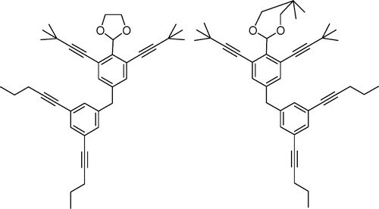
In brief, follow these points and you can expect to excel in organic chemistry:
• DO NOT FALL BEHIND ~ NOT EVEN ONE DAY.
• Maintain a positive attitude
• Do the reading assignment

• Take lecture notes and participate
• Review your notes and start HW assignments soon after lecture
• Actively prepare for and participate in CLASS
• Re-do HW problems without “cheating” to study for tests ON YOUR OWN
• Keep an organized, working record of concepts/problems that are difficult for YOU.

Study Tips (just a few more…)

Stay organized. Be a nerd about this, seriously.

Studying for exams:
Studying with groups is great, but it has to be in addition to studying alone. Your classmates cannot help you during the exam. Reading your notes and re-doing problems we do as a class is key.

Re-do as many worksheet & homework questions as you can, as many times as you can. Don’t just look at a problem and say, “I know how to do that.” Actually write it out again (a dry erase board can be useful for repetition without wasting paper).

Other Tips for Success and/or Maintaining Sanity:

Patience.

Some things will not make full sense right away. Letting this bother you only slows your progress.
Instead, accept it and enjoy the process. Your career is for the long haul, after all.
Also keep in mind that no two students are the same. You can expect to learn at a
different pace than your classmates. University life is actually all about figuring out how YOU learn.

Breathe and Get Out!

When feeling frustrated, take three deep breaths and start again fresh. Stress and frustration can also be alleviated with physical activity. Students tend to get caught up with classes, labs, work, sports, studying, partying, eating, etc. and exercise falls by the wayside. If you are feeling particularly overwhelmed or otherwise stuck, get up and go for a walk, run, or a bike ride. Try a yoga class or pick a sport and go do it! Sometimes when you just want comfort food, you’d probably be better off getting some exercise or at least some fresh air.

Don’t forget to SLEEP ~ 8 hours / night recommended.

And last but not least ~ enjoy the journey ~ have some fun with it

